Mission space lab JBVK report

Date June 2022

Team name: JBVK

Chosen theme: Life on Earth

Organisation name: n/a

Country: UK

1. Introduction

We have aimed to investigate if clouds have a pattern of cover depending on the time of day. This will be useful for weather forecasters (such as the met office).

We have predicted multiple things by different members of JBVK;

1. There will be more cloud in the morning than the afternoon this is because in the afternoon the wind will blow the clouds away
2. The second one was that there will be more cloud in the afternoon as the sun will heat the water in the morning to make more clouds throughout the day.

2. Method

We decided to measure the cloud coverage at different times of day using the camera. The camera took photos and these are stored as JPGs. We then processed the picture and tried to estimate how much of the picture is covered by cloud:

1. open the image
2. rotate the picture - we think it is upside down?!
3. Crop the photo to remove the window frame
4. Get the Saturation and Brightness of each pixel in the picture
5. Apply threshold - if the number is less than saturation threshold AND more than brightness threshold then we treat it as cloud
6. Work out the percentage cloud cover by adding up all the cloud pixels and dividing by total pixels

Next we put it in a CSV file along with the time, location and if it is day or night. The code takes a picture and calculates cloud cover every 15 seconds for 3 hours. At the end we have a big table of results to make a conclusion.

3. Experiment results

We collected 633 photos. In general the results are good because we collected a range of different amounts of cloud – from fully cloudy to basically no cloud.

**Least amount of cloud (6.3%): photo_0065.jpg**

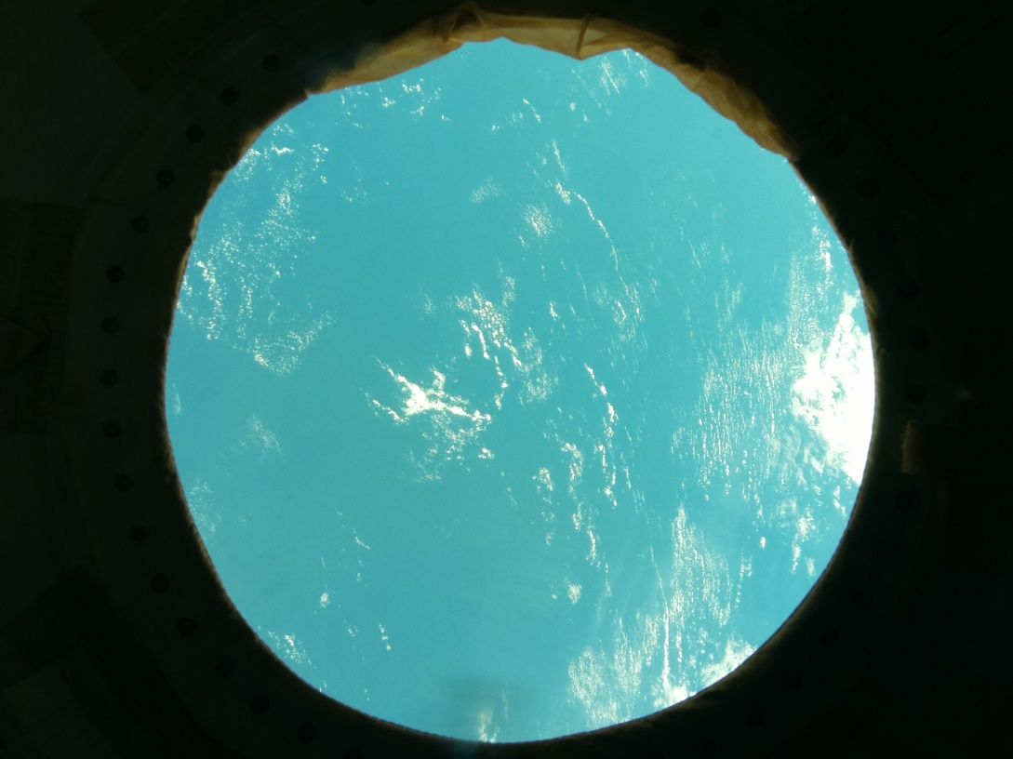

**Most amount of cloud (89.0%): photo_0173.jpg**

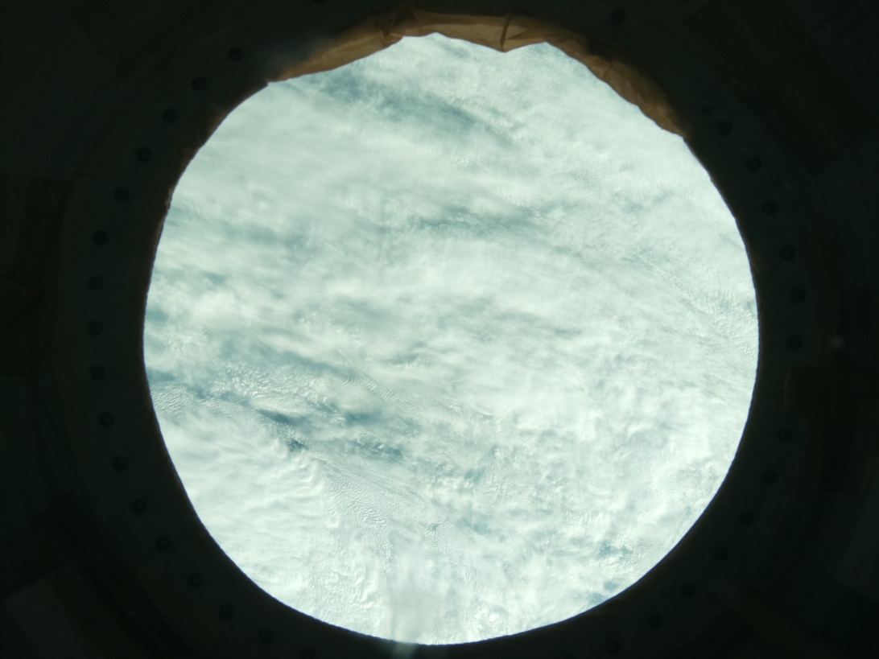

We opened the CSV file in Excel and plotted the results. This shows the local time at the bottom and the percentage of cloud amount up the side:

**Results graph**

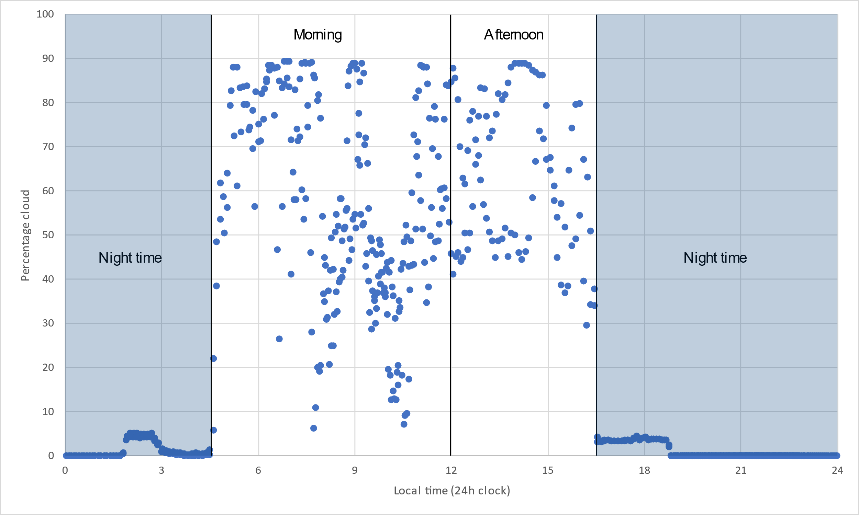

The result shows that we can’t measure cloud during night time. So we will ignore those results.

In our results the morning is longer than the afternoon.

We can’t see a very clear pattern that it is cloudier in the morning or in the afternoon. But it is a bit cloudier in the afternoon. We can see this from the average cloud. We can find out the average by adding together all of the percentage cloud amounts and dividing it by how many there were.

* Average cloud cover in morning: 56%
* Average cloud cover in the afternoon: 62%

So it is more cloudy in the afternoon, but not by much.

**4. Learnings**

● How did you plan and organise your work as a team?

*dddd*

● What challenges did you experience and how did you overcome them?

*dddd*

● What did you learn?

*dddd*

● What would you do differently next time?

*Dddd*

**5. Conclusion**

Taking part in AstroPi was great fun and seeing our results from the experiment was exciting. Everybody in the team learnt about coding and how to do an experiment.

The best bit about the project was: sdfsg

We think our experiment was a success because we could measure the cloud cover using our code. The result was not super clear, but we did find that it is a bit more cloudy in the afternoon. We predict this is because the sun will heat the water in the morning to make more clouds throughout the day. We would like to run the experiment for longer (like a whole year!) to see if our result is true every day. We think this would make the result clearer.

Thank you to ESA and Raspberry Pi for such a fun project.